Expenses requiring reimbursements
February 2023
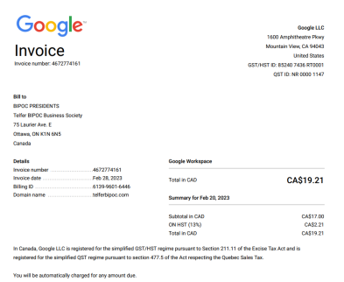
April 2023
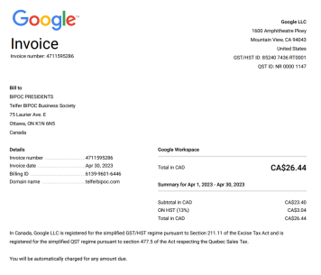
June 2023
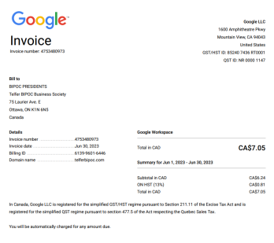
August 2023
1. Google invoice 7
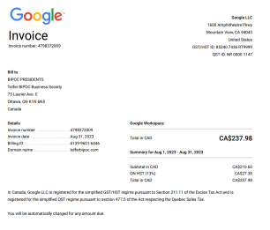2. Canva invoice
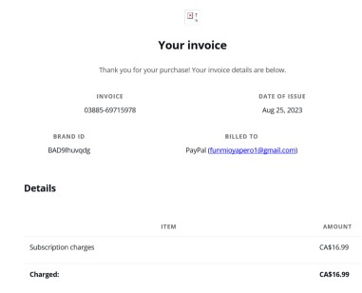
September 2023
1. Calendly invoice 2
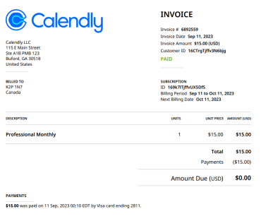
December 2023
Wix expense
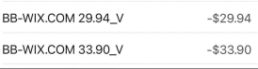
Canva expense

January 10, 2024
Merch expense
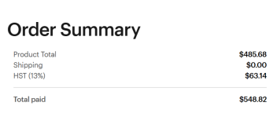
February 1, 2024
Canva expense
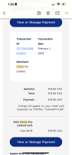
Wix expense:
March 1st, 2024
WIX subscription
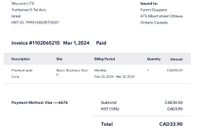Canva subscription

High School Student Visit
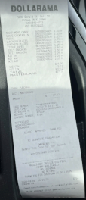
April 2024
DELOITTE AND BINGO GAMES EVENT RECEIPTS
LINKEDIN QR CODE RECEIPTS
GRAD SASHES
Canva Subscription

